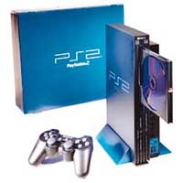
The Sony Playstation 2... Successor to the original and is considered by the most as the best & most popular console of it's generation.
The PS2 has the ability to play the games of the older Playstation 1.
Specs:
- CPU: Emotion Engine 300MHz, 128-bit INT, 128-bit FP, 24KB L1, 16KB Scratch, 8KB VU0, 32KB VU1, 450 MIPS, 6.2 GFLOPS, 66M Vertices/Sec, 2.4 GB/s Internal, 1.2 GB/s Graphics, 3.2 GB/s Memory
- Graphics: Sony GS 150MHz, 1.2G Texels/Sec, 32-bit Color, 4MB (48 GB/s), 1.2 GB/sec Bus
- Sound: SPU2, 48 2D Voices, ADPCM, 2MB
- Data: 24MB (2.6 GB/s), 16MB (81 MB/s), 4.7GB Discs, Expansion 56K Modem Ethernet

